Bandit Level 8
DG Interns Hub | Week 1 | OverTheWire Bandit Writeup

Objective
Find a password next to a specific keyword.

Activity summary
Suggested learning command / approach: grep millionth data.txt. Use only on the authorized OverTheWire training environment.

Key learning
Searching text with grep.

Evidence
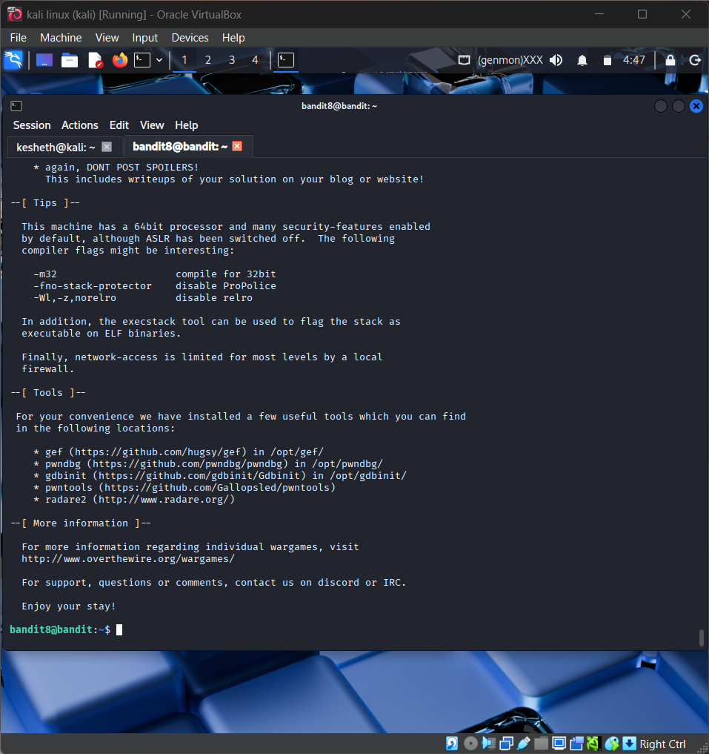
Screenshot: Bandit_Level_8.png
The screenshot is evidence of level activity/login; it may not show every solution step. No passwords are reproduced.

